

Cisco Unified Communications Manager

IP Communicator

Install Guide

**CONTENTS**

# Installing the Cisco Communicator Application

## Step 1

Open a ticket on the IT Helpdesk and assign to the Telecommunication Queue.

The Ticket should contain the following:

User Full Name:   
User ID:   
User Extension:   
User Location:

The Telecommunication department will then configure the appropriate telephony system that is the home system for the user. Once the configuration on the system is complete, the software can be installed on the user’s laptop or PC.

## Step 2

Obtain the software from the specified location. This will either be specified in the updated helpdesk ticket or it will be stored locally and the locations should be made known to the local IT.

The file to be used is “CiscoIPCommunicatorSetup.exe”  
The current tested version is 7.0.5.0 (do not use 7.0.6.0 or 8.0.0.0)

If possible ensure the desired headset is also plugged in and has been detected by Windows prior to commencing the install

## Step 3a Win XP

1. Log into the user device with a minimum of local Administrator rights.
2. Got to the storage location of the exe file
3. Start the install of the software by double clicking on the exe file

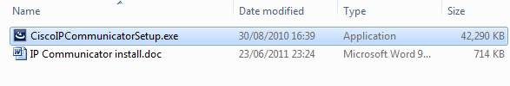

## Step 3B Win 7 (to avoid install issues)

1. Log into the user device with a minimum of local Administrator rights.
2. Got to the storage location of the exe file
3. Start the install of the software by right clicking on the exe file and select ‘Run as Administrator’

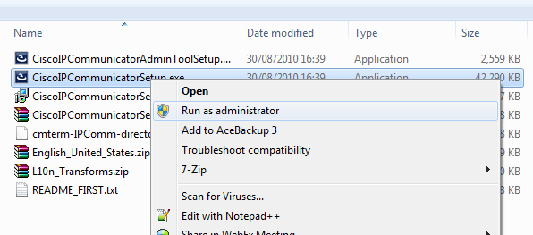

## Step 4

Select the English (United States) Language setting (This is the default). And click OK

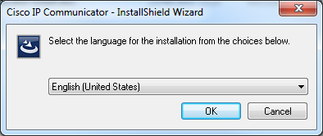

The following screen will be displayed

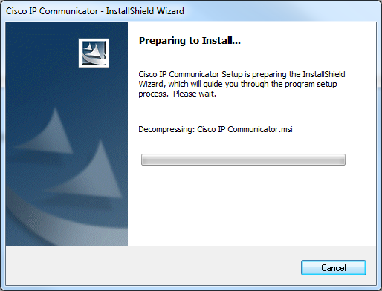

## Step 5

After decompressing the install file displays the welcome screen. Click next to continue.

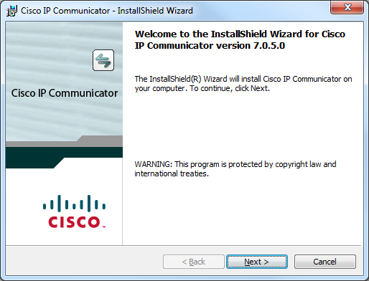

## Step 6

Accept the licence agreement. Click Next

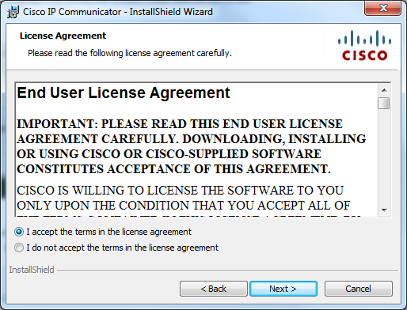

## Step 7

Accept the default install location. Click Next

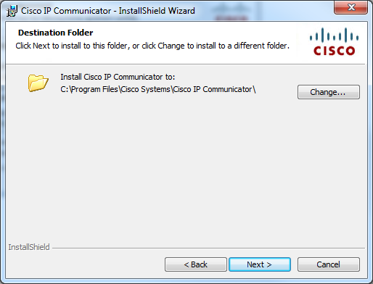

## Step 8

This is the last stage you can review the install parameters. Click Install when ready to proceed.

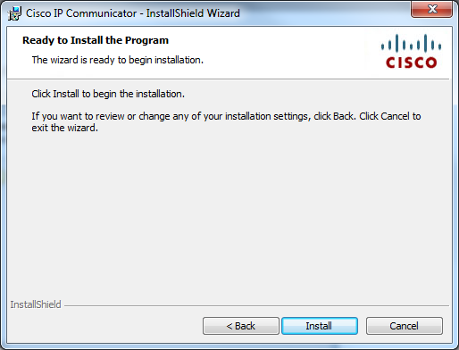

## Step 9

The install process begins.

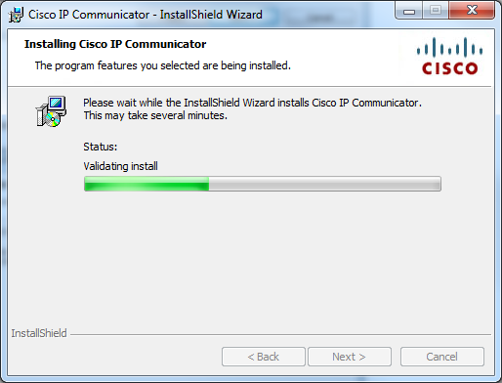

It will install all the required components and you may see a few quick pop up windows as part of this process but there is no need for any user intervention.

## Step 10

Once the install is complete the following window will be displayed.

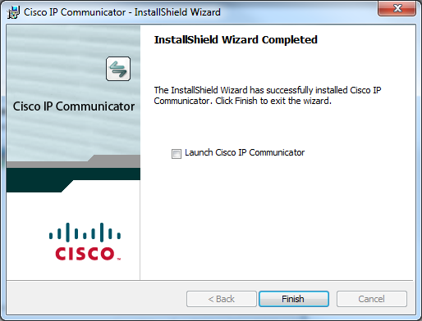

Select the Launch Cisco IP Communicator Option to start the application. And Click Finish

# Configuring the applications

## Step 1

The audio tuning wizard appears first. Ensure the headset is plugged in. Press Next

**Note:** If you do not have a headset Press Cancel. Details of how this can be done after initial configuration will be given later.

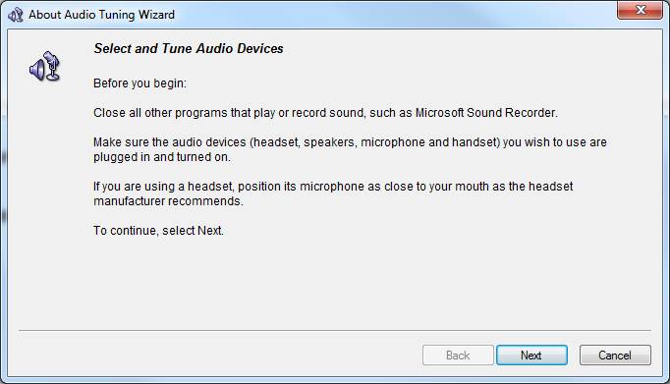

If you press Cancel you will be given the following warning. Select Yes and go to Step 5

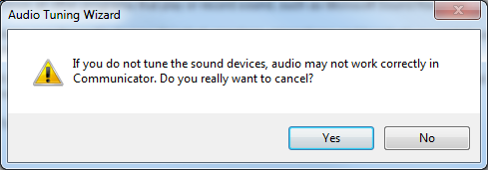

## Step 2

Select the appropriate device for the Headset, Speakerphone, handset and Ringer. It is best to set them all to the same device. Click Next

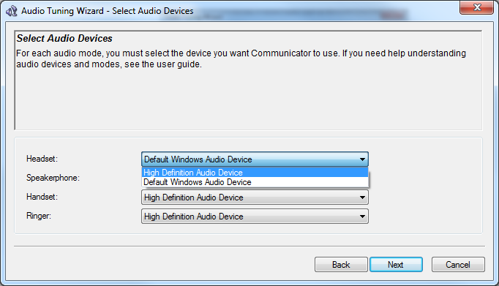

## Step 4

Do a sound speaker test. By pressing Play. You should hear sound out the speakers or headset speaker(s). Once you press the Play button the Next option will appear.

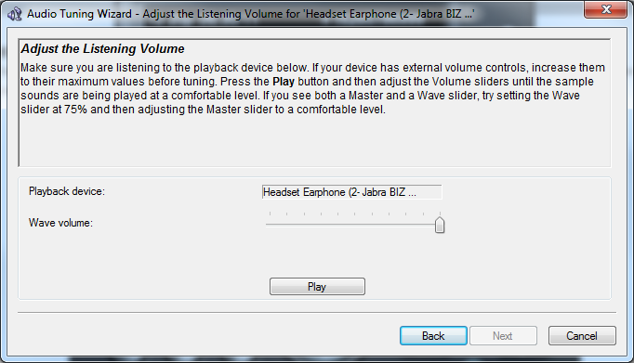

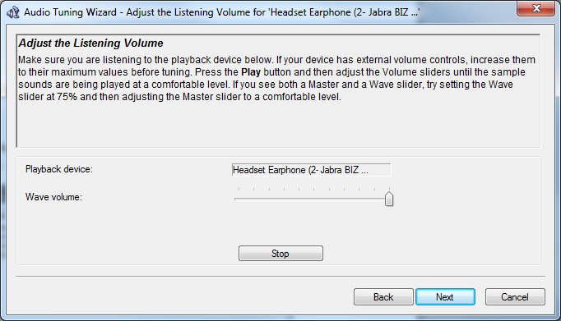

Press Stop and Next or just press Next

## Step 4

Perform a Microphone test by pressing the Test button and speak into the mic. Once you press the test button the Next option will appear.

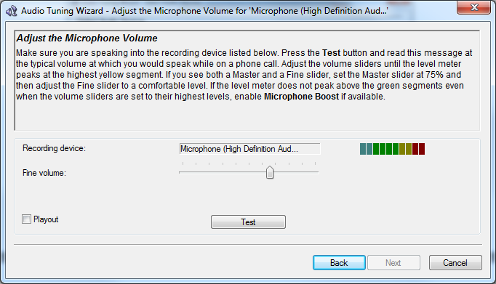

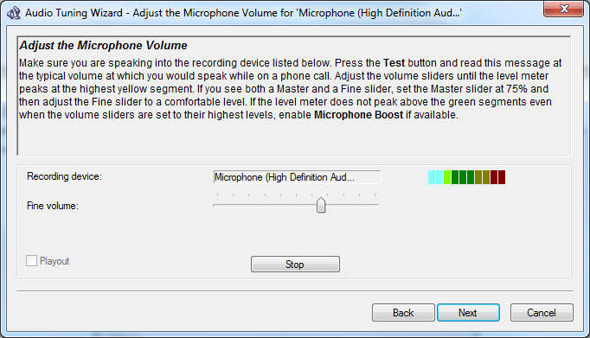

Normal talking should show the green bars lighting up. Press Stop and Next or just next

## Step 5

You have now completed the audio tuning. Press Finish

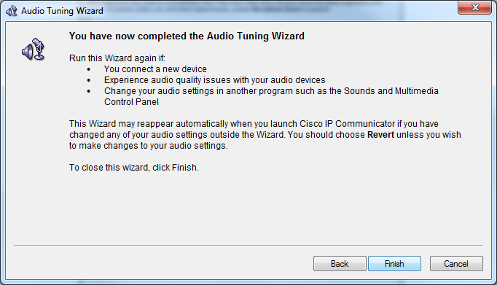

## Step 6

The following screen displays. Click OK

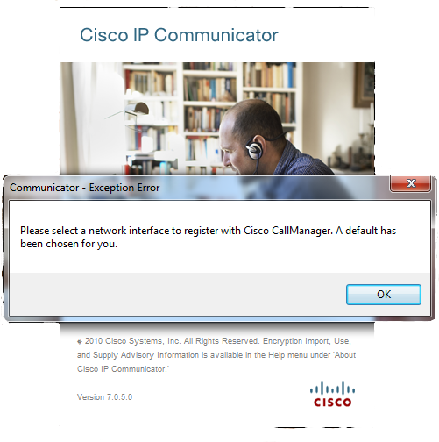

## Step 7

Enter the following details

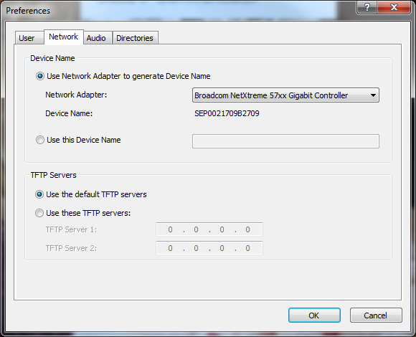

In the TFTP Server field Select “Use these TFTP Server”. In TFTP Server 1 enter the IP address for the desired site

Pasadena - 10.64.41.2  
Reading – 10.160.8.2  
Glasgow – 10.163.128.10  
Boston – 10.109.112.10  
Cologne – 10.142.134.4  
  
Note: this is the server of the cluster that the device and site a registered to.

In the “Use this Device Name” field enter the user ID

The result should be the following

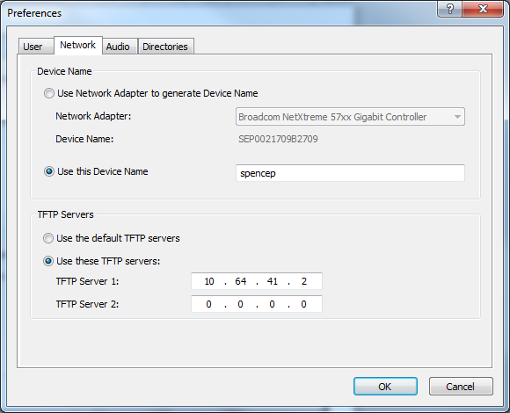

Click the Audio Tab and ensure the Optimize for Low bandwidth is **not** checked. Click OK

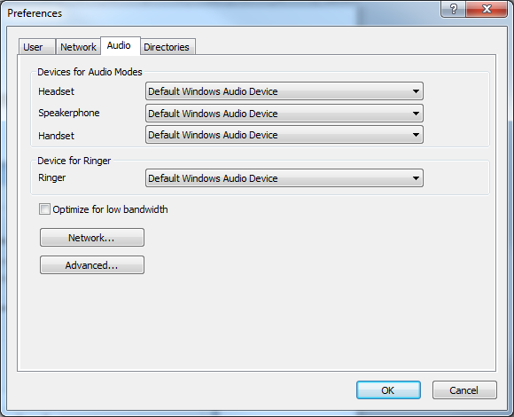

## Step 8

The following display appears. The softphone will update its locale. And you may also see a small popup window with bars whilst it downloads the appropriate local

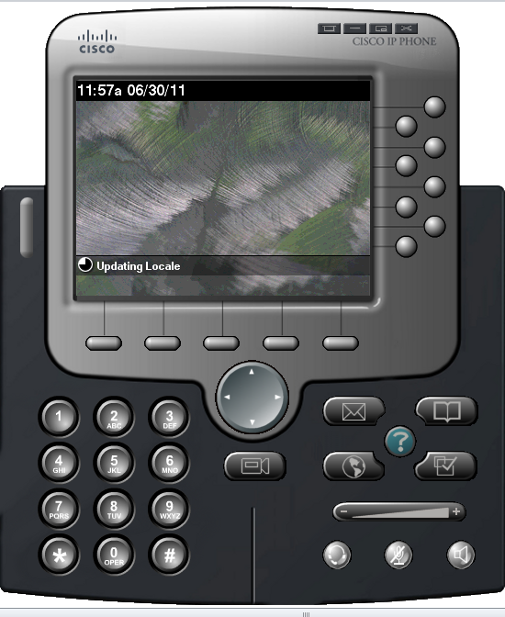

## Step 9

Once complete the screen will display the phone in it logged out state

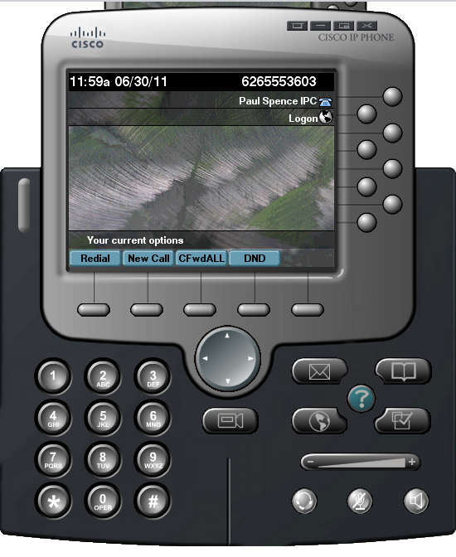

Select Logon or Select Services>Extension Mobility. The Service>Extension Mobility displays the following screen

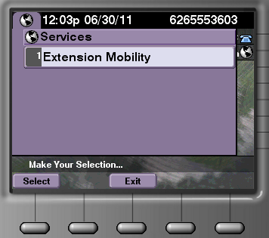

## Step 10

You will then be prompted for the User ID and PIN.

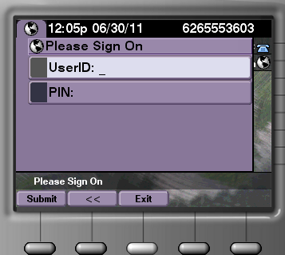

Enter as appropriate and press Submit

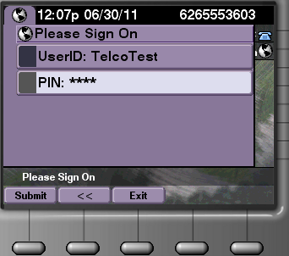

The login should be successful if the correct ID and Pin are used

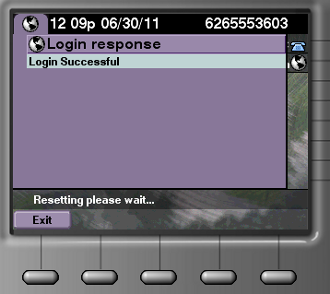

## Step 11

Call can now be made as if at the desk phone.

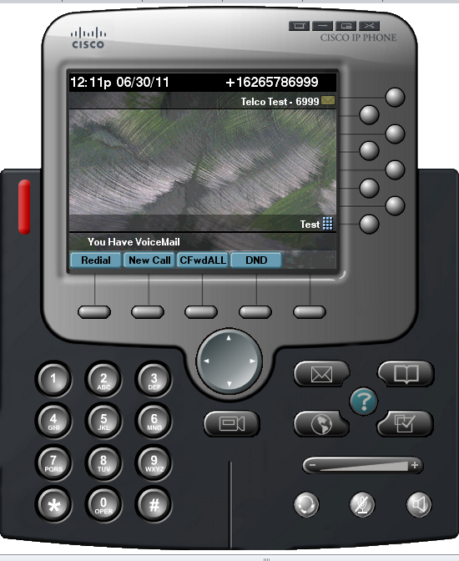

# To Audio Tune after install.

If the headset was not available or you have a replacement headset you can audio tune after the main installation and configuration at any time.

## Step 1

Place the mouse over the phone display and right click the mouse. A menu will appear. Select the Audio Tuning Wizard

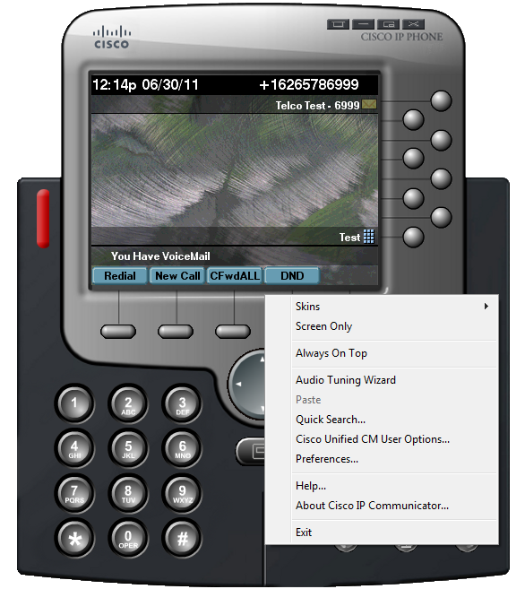

This can also be accessed from the Menu button

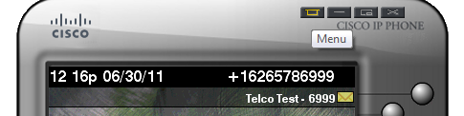

## Step 2

The audio tuning wizard appears. Ensure the headset is plugged in. Press Next



## Step 3

Select the appropriate or new device for the Headset, Speakerphone, handset and Ringer. It is best to set them all to the same device. Click Next

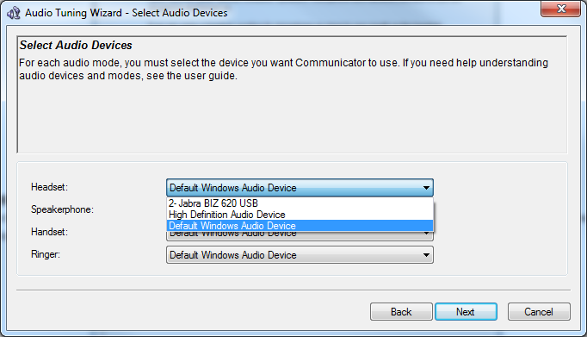

## 

## Step 4

Do a sound speaker test. By pressing Play. You should hear sound out the speakers or headset speaker(s). Once you press the Play button the Next option will appear.





Press Stop and Next or just press Next

## Step 5

Perform a Microphone test by pressing the Test button and speak into the mic. Once you press the test button the Next option will appear.





Normal talking should show the green bars lighting up. Press Stop and Next or just next

## Step 6

You have now completed the audio tuning. Press Finish



# To change the TFTP Server or User ID

There may be occasion where you need to change the server or user ID this can be performed as shown

## Step 1

Place the mouse over the phone display and right click the mouse. A menu will appear. Select Preferences



This can also be accessed from the Menu button



The preference Window will appear and you can amend accordingly as described above

